**3.2 SYSTEM FLOW DIAGRAM**

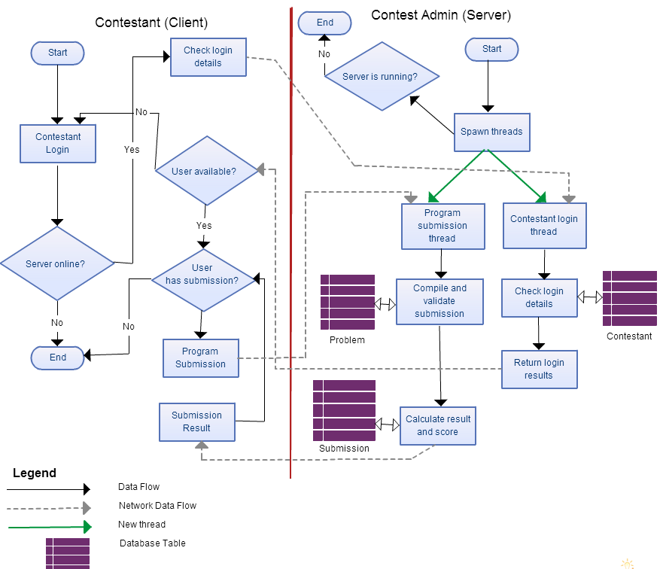

Fig. 3.3 : System Flow Diagram

**3.3 E-R DIAGRAM**

An entity relationship diagram (ERD) shows the relationships of entity sets stored in a database. An entity in this context is a component of data. In other words, ER diagrams illustrate the logical structure of databases.

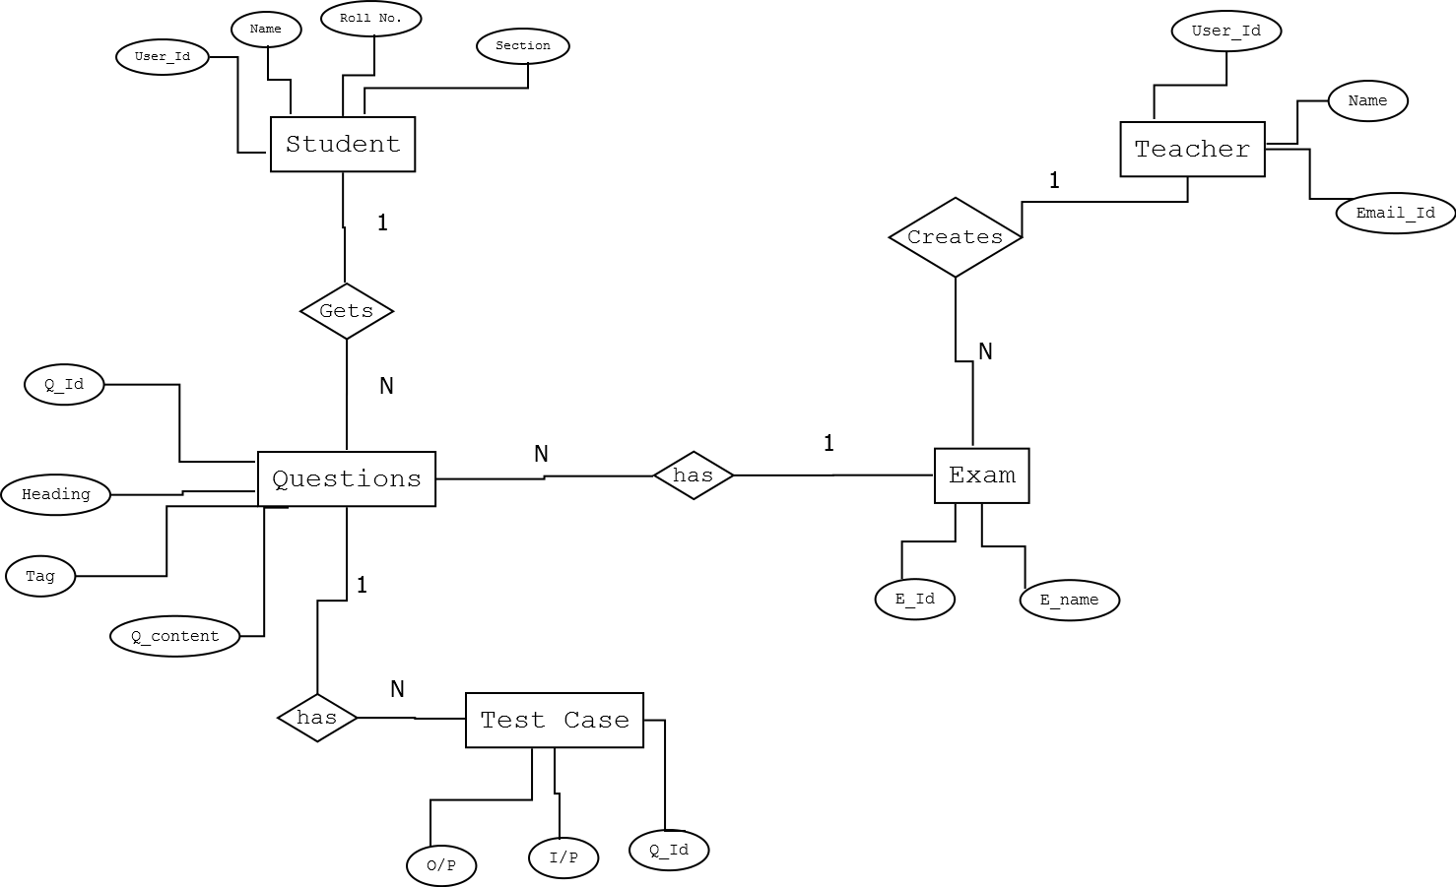

Fig. 3.4 : E-R Diagram

The ER Diagram gives complete picture of the system its entities, relations between them and the connection of the database in the whole system. As the figure depicts that the student can attempt questions that are there in the exam created by the teacher.